GE23131-Programming Using C-2024

Roll No : 240801145
Name : KAMESH . J

Week 3-1 :
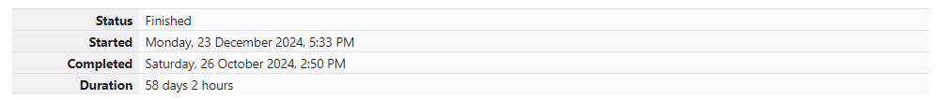

Problem 1:
Write a program to read two integer values and print true if both the numbers end with the same digit, otherwise print false.
Example: If 698 and 768 are given, program should print true as they both end with 8.

Sample Input 1
25 53

Sample Output 1
false

Sample Input 2
27 77

Sample Output 2
true

CODE:
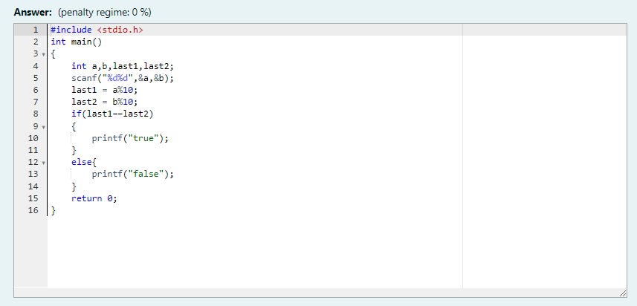

OUTPUT:
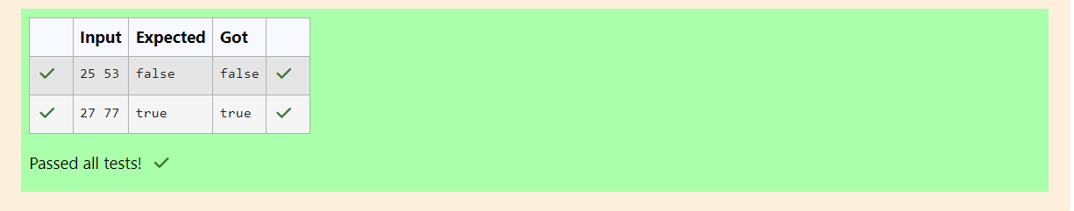

Problem 2:
In this challenge, we're getting started with conditional statements.
Task
Given an integer, n, perform the following conditional actions:
• If n is odd, print Weird
• If n is even and in the inclusive range of 2 to 5, print Not Weird
• If n is even and in the inclusive range of 6 to 20, print Weird
• If n is even and greater than 20, print Not Weird
Complete the stub code provided in your editor to print whether or not n is weird.

Input Format
A single line containing a positive integer, n.

Constraints
• 1 < n < 100

Output Format
Print Weird if the number is weird; otherwise, print Not Weird.

Sample Input 0
3

Sample Output 0
Weird

CODE:
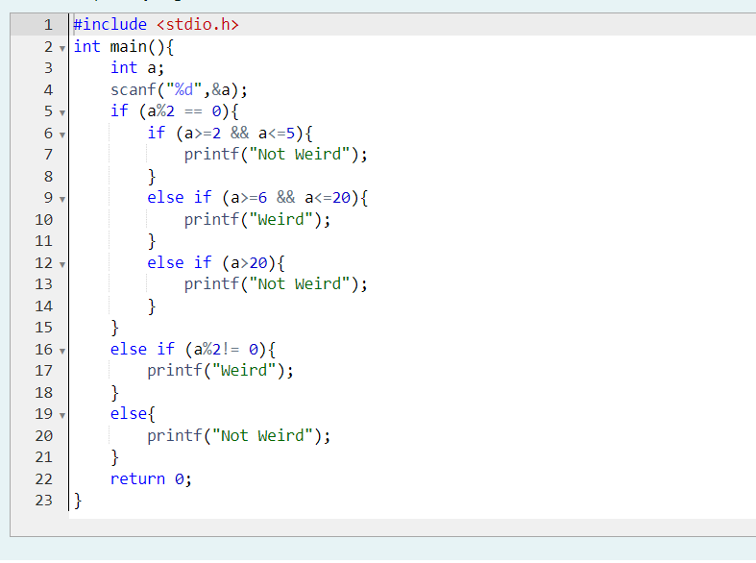

OUTPUT:
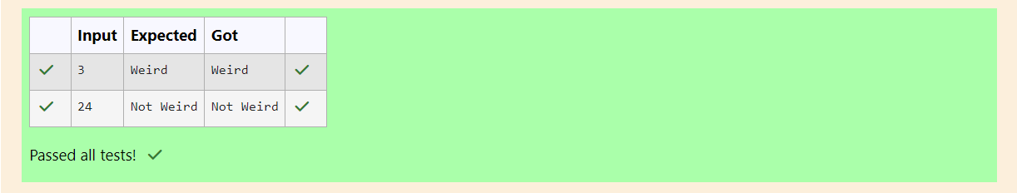

Problem 3:
Three numbers form a Pythagorean triple if the sum of squares of two numbers is equal to the square of the third.
For example, 3, 5 and 4 form a Pythagorean triple, since 3*3 + 4*4 = 25 = 5*5
You are given three integers, a, b, and c. They need not be given in increasing order. If they form a Pythagorean triple, then print "yes", otherwise, print "no". Please note that the output message is in small letters.

Sample Input 1
3
5
4

Sample Output 1
Yes

CODE:
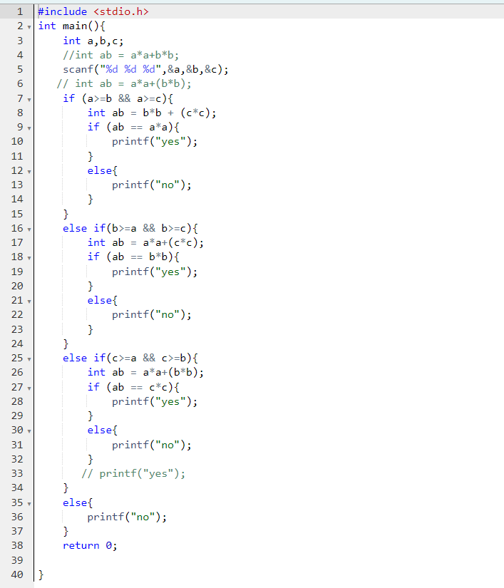
OUTPUT:
